Grammars
In languages, sentences are made up of words. Words are categorized into parts of speech, such as nouns, verbs, adjectives, adverbs, and prepositions. The grammar of a language is a set of rules which says how these parts of speech can be put together to make grammatical, or 'well-formed' sentences. While it makes sense to say "Put some paper in the printer," it does not make sense to say "Printer some put the in paper." Programming languages also have grammars that describe how "sentences" in the programming languages are formed.
When we wish to define the grammar rules of a language, we have to use notation (often involving the same alphabet that is used in the language) to describe the rules for forming strings of symbols. We need to be able to distinguish symbols appearing in the grammar rule that are part of the rule itself from symbols that are part of a properly formed string of the language. Bacus and Naur developed a notational scheme, BNF, for such syntax descriptions.
The meta-symbols of BNF are:
::= meaning "is defined as"
| meaning is "or"
<> angle brackets are used to surround category names
The angle brackets distinguish syntax rule names (also called non-terminal symbols) from terminal symbols which are written exactly as they are to be represented. A BNF rule defining a nonterminal has the form: nonterminal ::= sequence-of-alternatives consisting of strings of terminals or nonterminals separated by the meta-symbol | Granted, this appears to be quite strange and you may wonder how this is helpful for any language. BNF provides a standard method for representing the grammar of any language. This means that anyone reading the BNF for a grammar should understand it. In this course, we want to read descriptions of languages written in BNF. We define a C++ positive integer in the following manner:
<positive integer> ::= <digit> | <digit><positive integer>
<digit> := 0 | 1 | 2 | 3 | 4 | 5 | 6 | 7 | 8 | 9
These rules tell us we can replace <positive integer> with <digit> or <digit>< positive integer>. Keep in mind that anything in angular brackets is a non-terminal. Our goal is to have a string of symbols without non-terminal symbols. You should recognize that <digit><positive integer> is a recursive definition because we used <positive integer> in the definition. We have defined digit as any of the ten digits 0 through 9. Those are terminal symbols and may appear in a C++ statement.
Given a string of symbols, we can determine if it is a valid C++ positive integer. If the string has one symbol and that symbol is one of 0 - 9, then the integer is a C++ positive integer. This is the base case - when the integer has one symbol and that symbol is among the nonterminal symbols of the language. If there is more than one symbol in the string and the first symbol is a digit, and the remainder of the string is a positive integer, then it is a C++ positive integer. This means we have to check the remainder of the string to be certain it satisfies the definition for a positive integer. Here is pseudocode to verify whether a string is a valid C++ positive integer:
bool is-Positive-Integer(string, position)
if length(string) - position == 0
if string[position] is 0, 1, 2, ..., 9
return true;
else
return false;
else
if (string[position] is 0, 1, 2, ..., 9)
return is-Positive-Integer(string, position+1);
else
return false;
Inductive Proof
When we discuss properties of things we deal not only with numbers but also with structures such as strings, lists, programs, and more complicated structures constructed from them. Do the objects we construct have the properties we expect? Does a program halt when it is supposed to halt and give the proper answer?
To answer these questions we must find ways to reason about the objects that we construct. One means of verifying that our structures are what we expect is to apply an inductive proof. A proof by induction has two standard parts. The first step is proving a base case. This establishes that the statement is true for some small value(s). This step is usually trivial. Next the inductive hypothesis is assumed. That is, we state we accept the inductive hypothesis to be true up to some limit k. Using this assumption, the theorem is then shown to be true for the next value, which is typically k + 1.
Prove that:
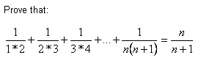
In this we want to show that the sum of the fractions whose numerator is 1 and whose denominator is the product of the next two consecutive integers is equal to the fraction
We first show the statement is true for the smallest possible value of n, which in this case is 1. We know the smallest value for n is 1 by the first fraction.
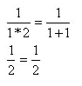
The two sides are the same. Now let's assume the statement is true for some value k,
So we know the following statement is true:
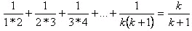 (1)
We will show the statement is true for k + 1 by adding the next term to the left side of the above equation and substituting k + 1 for k on the right side. Then we will simplify the left side and show the two sides are equal. We want to show this statement is true:
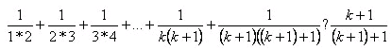 (2)
We will substitute for all terms on the left side of (2) except the last term using statement (1). Note the use of '?' between the two expressions. This will be used until we prove the two expressions are equal.
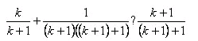
Now simplify the second term on the left side and find a common denominator for the two fractions on the left side. The common denominator is (k + 1)(k + 2).
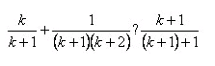
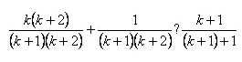 Multiply first term by 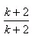
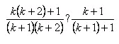 Add two fractions
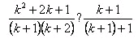 Multiply the numerator terms
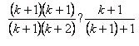 Factor the numerator
Now we can cancel the left side's common factor of k + 1.
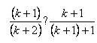 Write the numerator of left side as (k + 1) + 1
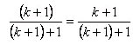
The two sides are in the same form, showing the statement is true for k + 1.

